|  |
| --- |
| Circle Language Spec |

## Pointers

### Brainstorm

The 'pointer-to-pointer' issues seemed to be a bit spread over the chapters. When a chapter would be explained, afterwards it seemed to evaluate how things could look in pointer-to-pointer situations. The idea is that all of those pointer-to-pointer situations might be put here in this chapter instead. Topics like objects, classes, interfaces, assignment, seem to able to live without thinking about pointer situations, and pointers just seems a single problem area that might be desirable to cover separately.

It might be worth highlighting there may be different interpretations of pointers, lines and their direction. They seem to be non-competing. Here is an attempt to summarize some of them:

* Interpretation 1:
  + Line direction would not matter, only aspect correspondence would matter.
* Interpretation 2:
  + Direction tends to point outwards, if inward, this would be denoted with an access symbol.
  + The notational choice would be arbitrary and carry no special meaning.
* Interpretation 3:
  + Directions tend to point outwards, if inward, this would be denoted with an access symbol, like previously.
  + Inward directions would actually be more 'active' redirections/accesses: Pointer-to-pointer redirections, getter accesses, calls to procedures returning an object, etc.
  + Outward directions, would be more passive. They might represent 'simple' pointers, not represent getter calls or anything, more like indications of aspect correspondence.
* Interpretation 4:
  + All symbols would be pointers, kind of like in some languages objects might be accessed through singly-redirected object references (C# assumably).
* Interpretation 5:
  + There would be one symbol in the diagram, that represents the actual object, not a pointer to it.
  + It might be found by first following all outward redirections, then all the inward ones.
  + Where it ends, might be the 'target' symbol: The actual target of the redirections that might be said to be represent the actual object, rather than just a reference to it.

### Brainstorm Ref-Ness

Another topic that might be covered, is a comparison with other languages (even though one of the strategic items is to not try and compare so much in this text, with the idea that 'where would it end?') An exception to the rule could be made here to add a comparison to other language's ref-ness, because Circle seems to be 'make a mockery' of the concept ref-ness in a way. C# or C++ seem to be specific about ref-ness. (C++ might make you specify asterisks ** to indicate how many redirections a pointer variable makes; C# and .NET seem to assign intrisic importance to defining parameters as ref or out and what other 'ref-nesses' have you? Anyway, they seem quite specific.) Circle however, seems to make a 'mockery' out of this, because all you need to do is add a line and the ref-ness changes. And the ref-ness does not seem to be specified near the start of the pointer redirection, but you might arbitrarily let redirections be added by the thing you are pointing to. 'mockery' is a meant a bit humoristically here, of course. It is just a notation. If the diagrams might represent something from C#, rules are probably just bound by what you can do in C#. You simply might not be able to add more redirections, or might not validly specify something with not enough redirection. Getter accesses in C# might actually be C#'s own embodiment of indeterminate ref-ness. Or depending how lightly you might want to apply the diagram language, it might not really matter that much, this ref-ness issue and these diagrams. But what might become a splinter in your brain, is that Circle does not seem to have a notation (yet) to specify fixed ref-ness. And what might rub some against the fur, is that Circle seems to like indeterminate ref-ness while some might hold determinate ref-ness in great value perhaps. The notion that there are these ideas about that, might justify thinking about it and perhaps describing a way to elegantly solve it or perhaps find a way to live with things the way they are.

### Target Objects

An object reference can* point to another object reference, which* points to another object reference and so on. The* first* object found in this redirection, that does not refer to another object again*, is called the* *target object*. Even* though* any of the* object *references* can be used like it is the* object itself, the* *target object* is considered the* real object and not just* a reference to it.

The* term target object is also used to denote the* direct* reference target, not necessarily the* final target. What kind of target is denoted, will be clear from the* context.

#### Compared to C++

In C++ you* had to specify* in advance* the* number of pointer redirections of a variable. In the* new computer language a symbol can follow any* amount of indirections, from zero* to infinity. You* do not specify* the* amount of redirections in advance*. You* can just add a redirection by turning* the* target object into a pointer.

#### In a Diagram

The* target object is the* last* point in a string of object reference redirections.

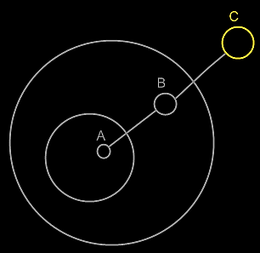

Symbol **A** is an object reference to symbol **B**. Symbol **B** is an object reference to symbol **C**. Symbol **C** is the* target object of both* symbols **A** and **B**.

The* idea of target objects is also* a way to make a single* symbol in the* diagram represent the* actual object, whereas the* others are just* seen as references to the* object: to have the* actual* object only* represented by a single* symbol in the* diagram.

### Target Classes

#### Concept

A target class is found by following the redirections, that lead to a symbol’s class.

Do not follow more than one class redirection, because if a class points out a class again, then the second class is *another* class object, that the first class is just *based* on. If the class is an object reference itself, you have to follow all object redirections to find the target class object. Then you have found the target class. That’s where redirection following ends. If the class object has a class itself, you might be tempted to follow the class object’s class redirections as well, to find the final target class, but you should not do that. The first class redirection indicates the class. If that class object has a class itself, then the class object is only based on another class, but it *is* a class on its own. An object redirection is just a much tighter bond like that, than a class redirection.

#### Diagram Notation

The concept of target classes is explained in the article *Target Classes*. This article only explains their expression in a diagram.

The target class is found by following the redirections, that lead to a symbol’s class.

When you want to find the class of an object, and the object is actually an object reference, you first need to follow all object reference redirections, to find the target object. When you found the target object, you can find the target class, by following one class redirection.

So to find the target class, you first follow *all* the object redirections, then *one* class redirections, then *all* the object redirections and there it ends.

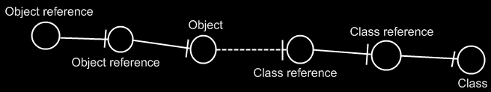

If the class has a class as well, this does not redirect the original object’s class, because the second class is *another* class object, that the first class is just *based* on. An object redirection is just a much tighter bond, than a class redirection.

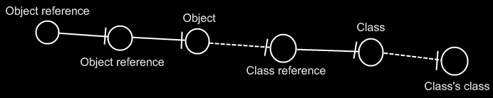

The target class of the first object reference is the symbol Class, not the symbol Class’s class. The same counts for the diagram below.

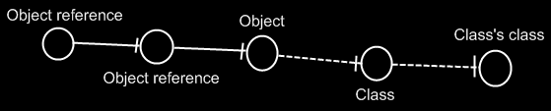

If you wonder what could be that different between Class and Class’s class: they could differ in default values. The main point is: finding the target class is about finding the class object.

### Multiple Class Redirections

Below is an example, with classes getting further redirected.

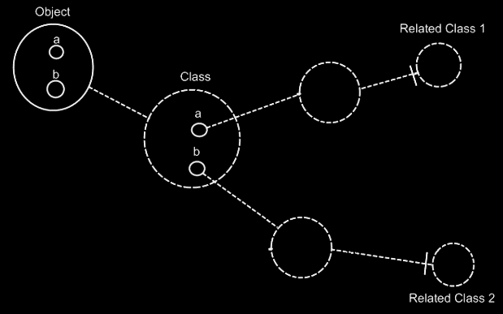

### Relation to a Pointer

#### Concept

As covered by the* article *Related Classes*, you* can* also establish a unidirectional relation with a *pointer* to another class. This is not* so common, but* it is possible all the* same. This is mostly applied, to allow a class to make a sub-object’s class *adjustable*. It is important to consider, that everything inside a pointer is really part of the* *target class*, but* a pointer itself is usable individually, independent from the* target class. This is well visualized in the* article *Relation to a Pointer in a Diagram.* To make a relation to a pointer bidirectional, you* have to give the* target class a relation back to the* first class. The* first class relates to the* pointer, but* the* target class relates back to the* first class. This automatically gives the* pointer a relation back to the* first class. This creates a bidirectional relation between the* first class and the* pointer to a class, but* only a unidirectional backwards relation between the* target class and the* first class. This is because* the* first class does not* directly refer to the* target class, but* the* target class does directly refer back to it. You* should see it in a diagram. That will make it much clearer.

#### Diagram Notation

You* can* also establish a unidirectional relation with a *pointer* to another class. This is not* so common, but* it is possible all the same.

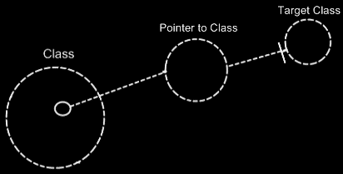

This is mostly applied, to allow a class to make a sub-object’s class *adjustable*.

It is important to consider, that everything inside a pointer is really part of the* *target class*, but* a pointer itself is usable individually, independent from the* target class.

To make a relation to a pointer bidirectional, you* have to give the* target class a relation back to the* first class.

The* relation back can* be displayed in both symbols, that represent the* target class:

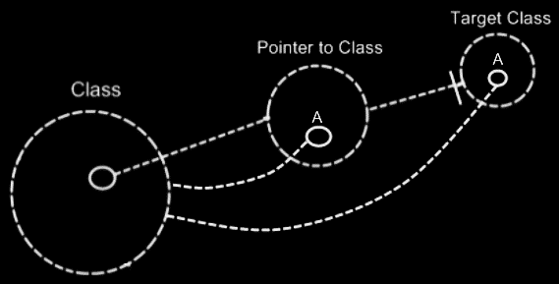

The* two unidirectional relations between **Class** and **Pointer to Class** melt together to a single bidirectional relation. But* the* unidirectional relation from the* **Target Class** to the* **Class** stays unidirectional, because* **Class** does not* directly relate to **Target Class**:

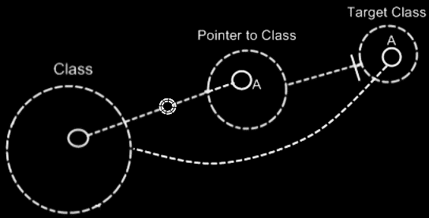

The* notation for a bidirectional relation was covered by the* article *Relations in a Diagram*.

So only **Class** and **Pointer to Class** get a bidirectional relation to eachother.

**Target Class** keeps a unidirectional relation to **Class**. Funny enough, that unidirectional relation is part of the* bidirectional relation between **Class** and **Pointer to Class**. The* bidirectional relation actually consists of:

- **Class** relates to **Pointer to Class**

- **Target Class** relates back to **Class**

The* connection between **Target Class** and **Class** is already implied by the* connection between **Pointer to Class** and **Class**. You’re* allowed to leave out of the* diagram then*:

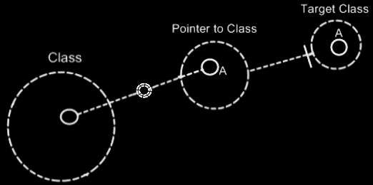

**Target Class** and **Class** are already implicitly related to eachother through the* pointer to the* target class.

In all the* diagrams above, that display the* backward relation, the* sub-symbols of **Pointer to Class** and **Target Class** were given a name: **A**. This was done, because* there was no line in the* diagram to indicate that they were the* same sub-object. Officially, when* symbols share an aspect, in that they are equal in object, class, interface or definition, they should be tied together with a line. Officially an object line should have been connecting both symbols of **A**:

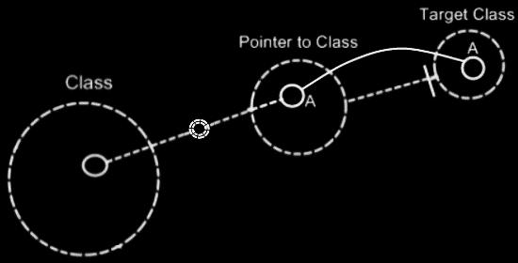

But* similarity in aspect can* also be implied by a *name* and the* *connection between parents*. This kind of implicit connection is explained in the* article *Automatic Containment*.

The* only point to implicit connection through parent is to make the* diagram clearer.

## Pointers and the System Interface

### System Objects

#### Pointer-to-Pointer

A related item can also wrap yet another related item, contained by another parent object.

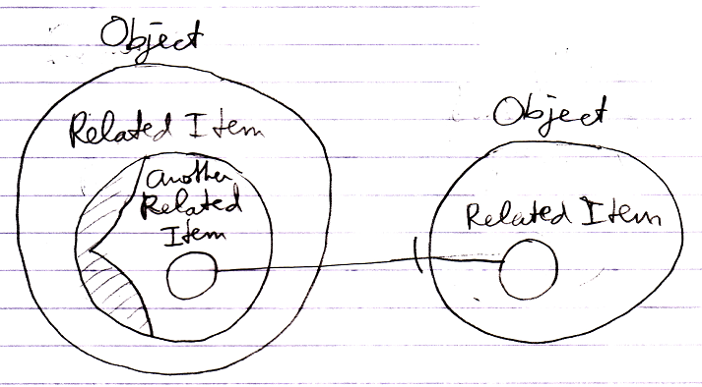

In that case it is said to be a *pointer-to-pointer*. The use of pointers to pointers makes you able to let something else determine what is eventually targeted.

You never work with objects directly, so even though the diagram above looks like a pointer, it is really a pointer-to-pointer.

### System Aspects

#### Reference

Sometimes no aspect of a reference is called upon, but there is worked directly with the reference itself. That is not really an aspect, but in that case it is said you are calling upon the **Reference** aspect.



#### Summary

This would add the following aspect to the list of aspects:

**Reference**

### Object-Bound & Reference Bound Aspects

The following aspects are reference-bound (or *sub-object-bound*):

**Reference**

### System Commands

#### System Commands for the Reference Aspect

The only system command for the **Reference** aspect is:

**Reference Get**

A reference can be a **Related Item** or a **Related List Item**. This creates two overloads for **Reference Get**:

**Reference Get 🡪 Related Item Get**

**Reference Get 🡪 Related List Item Get**

The reference aspect is used in pointer operations.

#### System Commands for the Object Aspect

All the standard situations seemed covered previously, but pointer-to-pointer situations make things more complex.

##### Pointer-to-Pointer

In a standard situation **Object Get** and **Object Set** control references to objects. However, a reference can also point to yet again another reference: to a related item contained by another parent object. This makes the other parent object decide which object is eventually pointed at.

As such, pointer-to-pointer functionality introduces extra commands.

##### Set Object to Reference

To be able to set the object aspect to another related item, **Object Set** has two overloads:

**Object Set** 🡪 **Set Object to Other Related Item**

**Object Set** 🡪 **Set Object to Other Related List Item**

If you want a single name to express both situations, you could call it **Set Object to Reference**.

##### Get Object which is a Reference

Because the object aspect can be another related item, the **Object Get** command gets two overloads:

**Object Get** 🡪 **Get Object which is Another Related Item**

**Object Get** 🡪 **Get Object which is Another Related List Item**

If you want a single name to express both situations, you could also call it **Get Object which is a Reference**. During execution these system commands call **Reference Get** on the other related item.

##### Use Reference As Object

The reference aspect can be access-controlled for the different ways you can use it. Pointer-to-pointer situations require you to be able to use a reference as an *object*. To be able to access control the different purposes for which you can use a reference, the **Reference Get** command gets the second implementation:

**Use Reference As Object**

which delegates directly to the **Reference Get** command.

##### The Overloads Recapitulated

Do not wreck your brain over all this delegation and overloading. It is just for pointer-to-pointer situations to have the same command names as standard situations, and also to be able to separately access control the specific *uses* of a reference. You will not usually see the pointer-related commands, because they will be implicitly delegated to by the main system commands.

This leaves us with the following command added for pointer-to-pointer situations:

**Use Reference As Object**

Detail: For that last command you might want to overload **Object Get.** But that does not work. You can not overload it, because they will both take a pointer to an object as an argument. To disambiguate, they have to have a different name and you have to point to a *specific* command.

#### System Commands for the Class Aspect

##### Pointer-to-Pointer Situations

In a standard situation the **Use As Class, Class Set**, **Reference-Class Get** and **Object‑Class Get** commands are about making an object function as another object’s class. However, you can also make something’s class be yet again another reference. That means that another parent object determines the eventual class.

(However, this might create difficulty for the system to maintain a constant class. You might want another parent to determine the initial class, but the class of an object should not change during its lifetime.)

##### Set Class to Reference

To be able to set the **Class** aspect to another related item, **Class Set** has two overloads:

**Class Set** 🡪 **Set Class to Other Related Item**

**Class Set** 🡪 **Set Class to Other Related List Item**

If you want a single name to express both situations, you could call it **Set Class to Reference**.

##### Get Class which is a Reference

Because the **Class** aspect can be set to another related item, the **Class Get** command gets extra overloads. Next to that, there are different overloads for the two types of **Class Get**: **Reference-Class Get** and **Object-Class Get**. This creates the following overloads:

**Reference-Class Get 🡪 Get Reference-Class which is Another Related Item**

**Reference-Class Get 🡪 Get Reference-Class which is Another Related List Item**

**Object-Class Get 🡪 Get Object-Class which is Another Related Item**

**Object-Class Get 🡪 Get Object-Class which is Another Related List Item**

You could also call them **Get Class which is a Reference**.

##### Use Reference As Class

The **Reference** aspect can be access-controlled for different ways you can use it. Pointer-to-pointer situations require you to be able to use a reference as a *class*. To be able to access control the different purposes for which you can use a reference, the **Reference Get** command gets the secondary implementation:

**Use Reference As Class**

which delegates directly to the **Reference Get** command.

##### The Overloads Recapitulated

Do not wreck your brain over all this delegation and overloading. It is just for pointer-to-pointer situations to have the same command names as standard situations, and also to be able to separately access-control the specific *uses* of references or objects. You will not usually see the pointer-related commands, because they will be implicitly delegated to by the main commands.

This leaves us with the following command added for pointer-to-pointer situations:

**Use Reference As Class**

Detail: For that last command you might want to overload **Object Get.** But that does not work. You can not overload it, because they will both take a pointer to an object as an argument. To disambiguate, they have to have a different name and you have to point to a *specific* command.

#### The Extra Commands & Overloads

The system commands for the **Reference**, **Object** and **Class** aspects introduce accessory commands and overloads. They seem to be making the explanations more complicated, but they actually make things easier to work with. There are reasons for the introduction of the extra commands and overloads:

- Common commands for related items and related list items

- Common commands for direct pointers and pointers-to-pointers

Here follows an overview of which reason applies to which command or overload.

##### Access-Control Usage

**Use Reference As Object**

**Use Reference As Class**

##### Common Commands for Related Items and Related List Items

**Reference Get 🡪 Related Item Ge*t***

**Reference Get 🡪 Related List Item Get**

##### Both

*- Common commands for related items and related list items and*

*- Common commands for direct pointers and pointers-to-pointers*

**Object Set** 🡪 **Set Object to Other Related Item**

**Object Set 🡪 Set Object to Other Related List Item**

**Object Get 🡪 Get Object which is Another Related Item**

**Object Get 🡪 Get Object which is Another Related List Item**

**Class Set 🡪 Set Class to Other Related Item**

**Class Set 🡪 Set Class to Other Related List Item**

**Reference-Class Get 🡪 Get Reference-Class which is Another Related Item**

**Reference-Class Get 🡪 Get Reference-Class which is Another Related List Item**

**Object-Class Get 🡪 Get Object-Class which is Another Related Item**

**Object-Class Get 🡪 Get Object-Class which is Another Related List Item**

Again: the reasons for extra commands, overloads and delegation are:

- Common commands for related items and related list items

- Common commands for direct pointers and pointers-to-pointers

### System Interfaces

#### System Interface of a Related Item

An additional aspect, that may apply to a **Related Item** could be:

**Reference**

##### The Reference Aspect in the System Interface

The **Reference** aspect is controlled through only one command:

**Reference Get**

The **Reference** aspect is placed inside a triangle, that wraps together the members to control the **Reference** aspect:

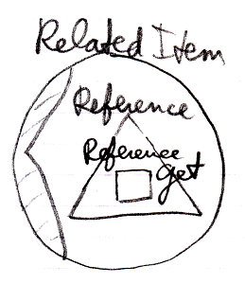

##### The Object Aspect in the System Interface

The **Object** aspect of a **Related Item** is controlled through an additional command:

**Use Reference As Object**

The commands are placed inside a triangle, that wraps together the members of the **Object** aspect:

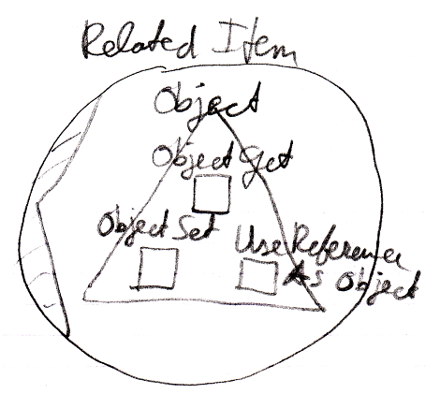

##### The Full System Interface for Related Item

The full system interface of a **Related Item** including pointer-to-pointer provisions may look like this:

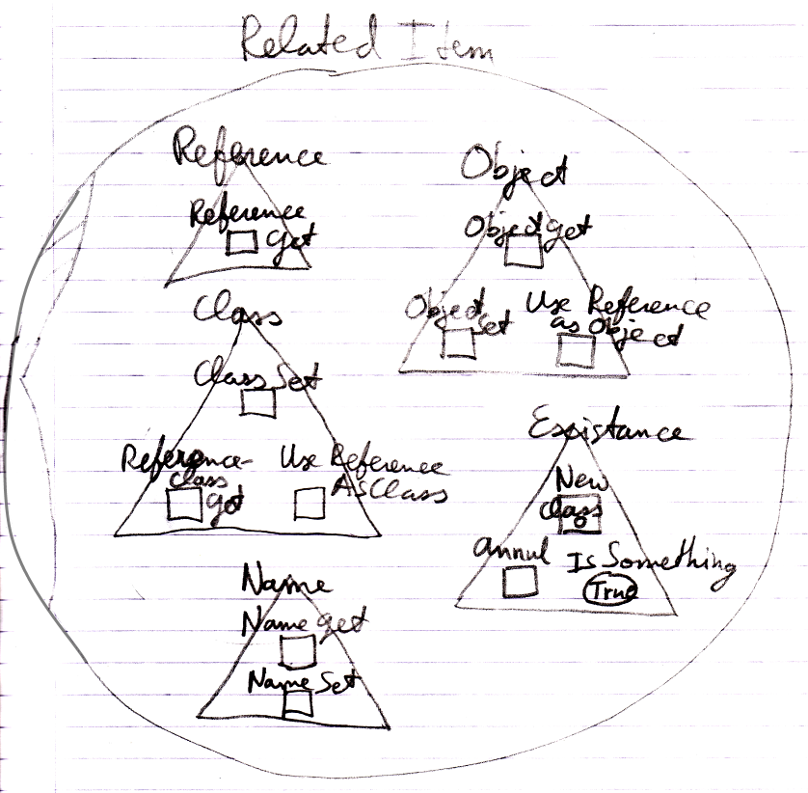

##### The Reference-Class Aspect in the System Interface

**Use Reference As Class**

The commands are placed inside a triangle, that wraps together the members of the **Class** aspect:

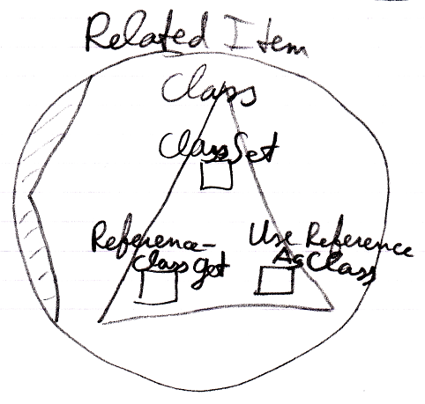

#### System Interface of a Related List Item

An additional aspects, that apply to a **Related List Item** is:

**Reference**

##### The Full System Interface for Related Item

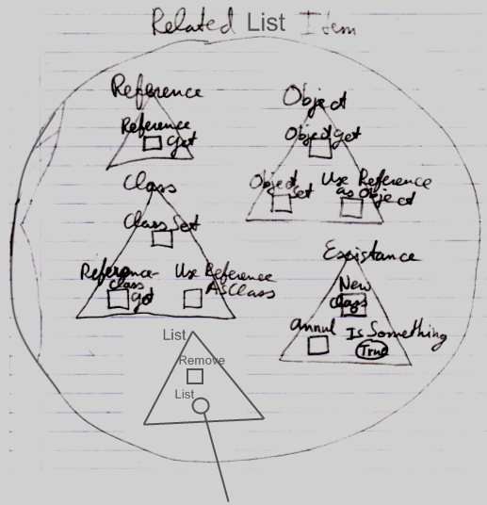

### Design Choices

#### 'Use' Command Gets Another Aspect

The **Use Reference As Object** command is part of the **Object** aspect but **Gets** the **Reference** aspect. The **Use Reference As Class** command is part of the **Class** aspect, but **Gets** the **Reference** aspect.

## Pointer Assignment

### Pointer Assignment

Next to assigning one object reference’s object to another object reference, you could also assign the object reference itself to another object reference. In that case the second object reference will become a *reference to an object reference*, instead of a reference to an *object*. This requires another type of assignment: a pointer assignment.

Pointer assignments establish a pointer-to-pointer. Instead of assigning a target object to the reference, you assign a reference to the reference. This creates a *pointer-to-pointer*, instead of a direct reference to an *object*. This allows another object reference to decide which object is eventually pointed at.

A pointer assignment always has a **Reference** as a source, not its **Object**, not its **Class**, but the **Reference** itself.

A pointer assignment is displayed with an arrow inside the diamond.

|  |
| --- |
| **Object Pointer Assignment:** |
|  |
|  |
| Reference Get 🡨  Object Set 🡪 (~= Set Object to Other Related Item) |
|  |
|  |
| Reference Get 🡨  Object Set 🡪 (~= Set Object to Other Related List Item) |
|  |
|  |
| Reference Get 🡨  Object Set 🡪 (~= Set Object to Other Related List Item) |

Pointer assignment also works for class assignment. You can use a reference as a class, instead using an object itself as the class:

|  |
| --- |
| **Class Pointer Assignment:** |
|  |
|  |
| Use Reference As Class 🡨 (~= Reference Get)  Class Set 🡪 (~= Set Class to Other Related Item) |
|  |
|  |
| Use Reference As Class 🡨 (~= Reference Get)  Class Set 🡪 (~= Set Class to Other Related Item) |
|  |
|  |
| Use Reference As Class 🡪 (~= Reference Get)  Class Set 🡪 (~= Set Class to Other Related List Item) |

### Assignment With Pointer Source

If something is already a pointer-to-pointer and it is the source of a conventional assignment, the target also becomes a pointer-to-pointer. Pointer assignments *establish* pointers to pointers, but in this case a pointer-to-pointer is already there.

So a conventional object assignment can also have the following implementations:

|  |
| --- |
| **Object Assignment:** |
|  |
|  |
| Object Get 🡨 (~= Use Reference As Object ~= Reference Get)  Object Set 🡪 (~= Set Object to Other Related Item) |
|  |
|  |
| Object Get 🡨 (~= Use Reference As Object ~= Reference Get)  Object Set 🡪 (~= Set Object to Other Related List Item) |

Assignment when source is pointer to pointer also works for the **Class** aspect:

|  |
| --- |
| **Class Assignment:** |
|  |
|  |
| Use As Class 🡨 (~= Use Reference As Class)  Class Set 🡪 (~= Set Class to Other Related Item) |
|  |
|  |
| Use As Class 🡨 (~= Use Reference As Class)  Class Set 🡪 (~= Set Class to Other Related List Item) |

### Cross-Aspect Assignment

If the source of the assignment is a pointer-to-pointer, then the target also becomes a pointer-to-pointer. So this also gives **Reference Class to Object** assignment the following implementations:

|  |
| --- |
| **Reference-Class to Object Assignment** |
|  |
| Reference-Class Get 🡨 (~= Other Related Item Class Get)  Object Set 🡪 (~= Other Related Item Set) |
| *Result:* |
|  |
|  |
| **Reference-Class to Object Assignment** |
|  |
| **Reference-Class Get 🡨 (~= Other Related List Item Class Get)**  **Object Set 🡪 (~= Other Related List Item Set)** |
| *Result:* |
|  |

### Cross-Aspect Pointer Assignment

*Pointer* assignments do not have a cross-aspect variation. Pointer assignments use an the reference aspect as the source of an assignment: not a particular aspect of the object reference, but the reference itself. It does not apply to cross-aspect assignments, because on one end of the assignment no aspect at all is involved.

## System Command Calls and Pointers

### System Interface Call

**Use Reference As Class**

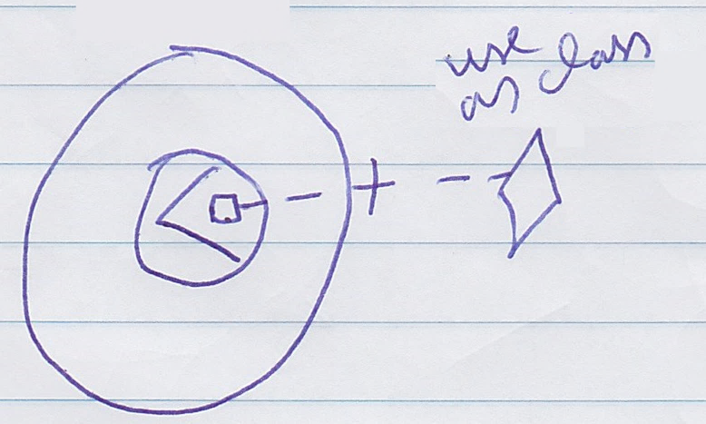

(has assignment notation)

### System Interface Call with Argument

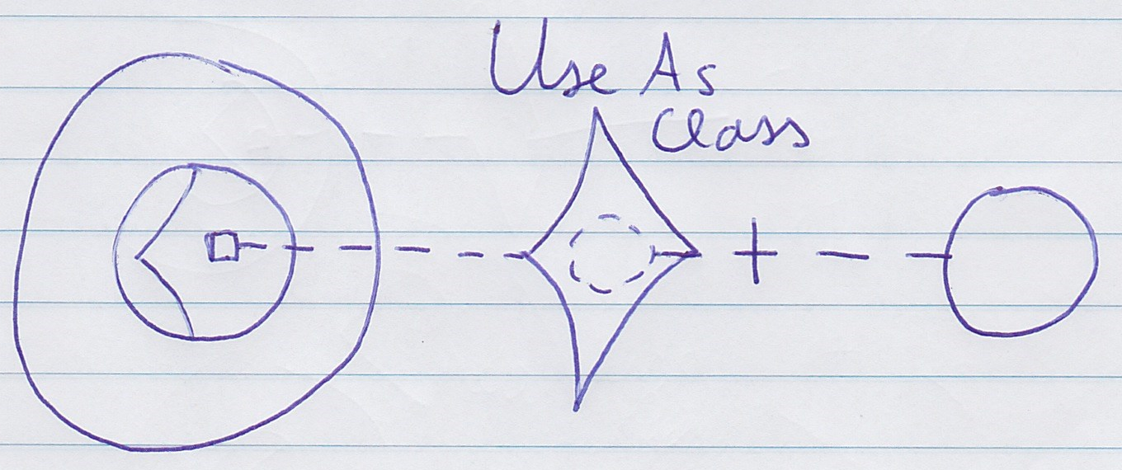

**Use Reference As Class 🡨**

**(Class Set 🡪)**

(has assignment notation)

## Loose Ideas

### Loose Ideas about Target Objects

Objects,

Target,

2008-07-26

I need to rename the* term Target Object, Target Class and Target Interface to Final Object Target, Final Class Target and Final Interface Target, because I’m not targeting an object, class or interface, but I’m targeting an object reference representing an object, class or interface.

Also the* term object target is the* same as direct object target. That also counts for classes and interfaces.

The* term Target Object, Target Class and Target Interface have less of a use now. But the* way they are used now is misleading.

JJ

(Out of the original Symbol documentation)

#### Object Trace

< 2008-10-06 Probably not right anymore. >

To find the* target object, you*’d expect to only follow object lines. However, there’s a pitfall: a situation that does not occur a lot, though.

If a type line points to a symbol with an object line, the* type is a single object.

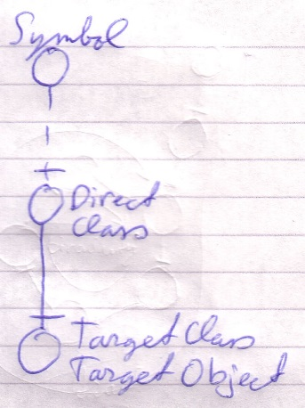

Each instance of the* type is actually the* same object.

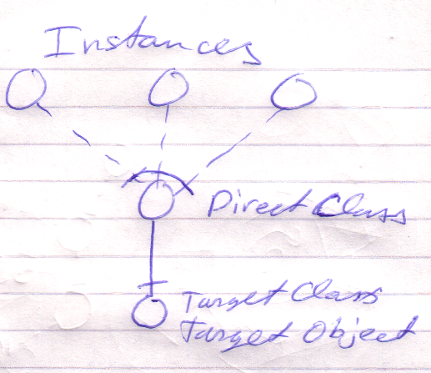

Therefore, a type line can redirect the* object of the* symbol. Therefore, type lines need to be followed to find the* object.

The* last symbol pointed to by an object line is the* object.

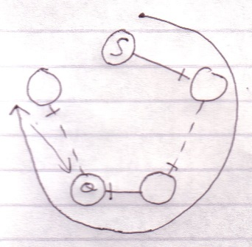

This kind of redirectioning is called an *object trace*.

Delegating the* object aspect is the* main type of object redirection.

#### Idea

In C++ bepaal je de redirection diepte vooraf:

Int ***TripleRedirected

In Symbol kan je de redirection diepte achteraf bepalen

Als je in C++ een object referenties toewijst aan een object referentie, dan wijs je niet naar de object referentie, maar naar het target object. Symbol heeft meer structurering hier.

#### Multiple Redirection and Final Targets

If an object symbol has an object line to a symbol that again has an object line, there is redirected until a symbol without an object line is encountered: the* *target object*.

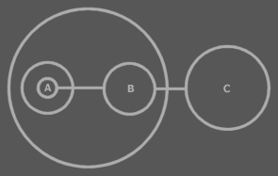

C is the* target object of A and B.

The* target object symbol is regarded to represent the* object for real. The* other symbols are references to the* object.

The* same way there are symbols serving as a *target type* or a *target interface*. Also a procedure has an interface target. A procedure also has a call target and reference target. In both those cases reference lines are followed.

### Loose Ideas about Target Classes

(Out of the original Symbol documentation)

#### Tracing Object Aspects

Formerly I’ve said that when you encountered a symbol that doesn’t have a type line, then it is the target type. But in *Object Basics* I said that when a symbol doesn’t have a type line, the object line functions as the type line. Therefore, if a symbol has no type line, the type can still be redirected by an object line.

Finding the aspects of a symbol, such as target object or target type, is called a *trace*.

##### Type Trace

You’ll use type and object lines to trace the type. Follow the type line if it exists, else follow the object line. When you run into a symbol with no type or object line, then that’s the type.

When there is no type line, the object determines the type.

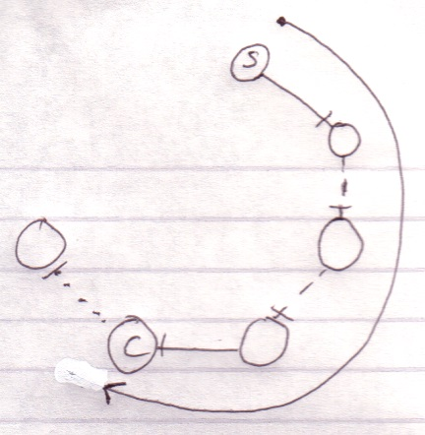

Interface lines are not followed. Note that the target type doesn’t have to be pointed to by a type line.

##### Object-Type Trace

The last symbol in the object trace altogether:

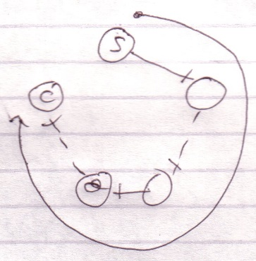

is the target type.

Therefore, *object* trace can also point out to the target *type*. The difference with a *type trace* is that a type trace prefers to follow type lines over object lines and an object trace prefers to follow object lines over type lines. However, both redirections lead to the exact same symbol.

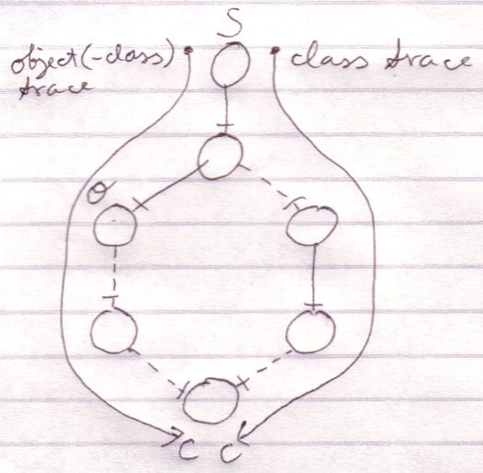

It happens a lot that you want to find out the object and the type in one blow. So you may as well use the redirection of the object trace for the benefit of finding the object and type in one blow. The trace is then called a *object-type trace*.

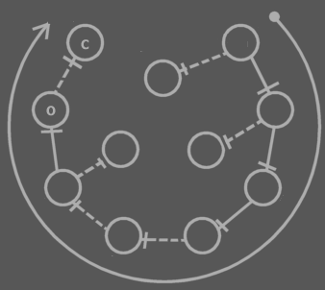

The last symbol in the redirection altogether is the target type (**C**). The last symbol pointed to by an object line is the object (**O**). Note that the target type may be pointed out by an object line.



When you only want to find out the type, it is better to use a type trace than it is to use an object-type trace. Type trace prefers type lines over object lines. Type lines generally follow less redirections before reaching the target type than object lines do.

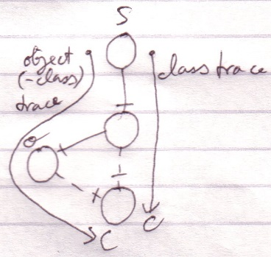

##### Tracing is Not Always Hard

If an object symbol has no object line or type line, then finding the target object and type is much simpler, because no redirectioning at all takes place. The symbol is its own object and type.



Traces usually don’t require as many steps as in the examples above.

Targets,

2010-05

> I do not know how it works yet. Now my mind says: follow all redirections, including multiple interface redirections… but in the Target Class story I stopped doing that. Maybe it is just what you want the term Target Interface to define. Maybe it is not even important. I don’t know.

> Perhaps there should be a distinction between interface definition and target interface. I do feel that both the ‘follow only one class or interface step’ version is a concept to be aware of, but the target interface concept would actually be following all redirections to find the object that actually determines the publics.

> Yes. What is now called Target Interface should probably be called the *Interface Object* and the *Target Interface* is the object after following all types of redirections in any order.

JJ

### Other Loose Ideas

Pointer to class of,

2008-08-17

Consider the notation of pointing to the class of an object reference, used in the article Class Referrers in a Diagram.

I need a notation for explicitly referring to a pointer or to the class of an object or to the class of an object reference.

Do consider that the target object in a diagram really needs to represents the object. You should not think of it as an object reference, because that will make it harder to see through the system.

> 2020-06-13: Might it be an idea to consult the system interface to point to the class of an object symbol? So the system interface might show the class and that bit of the system interface might be shown, and an object reference would point to the class indication in the system interface? Something like that.

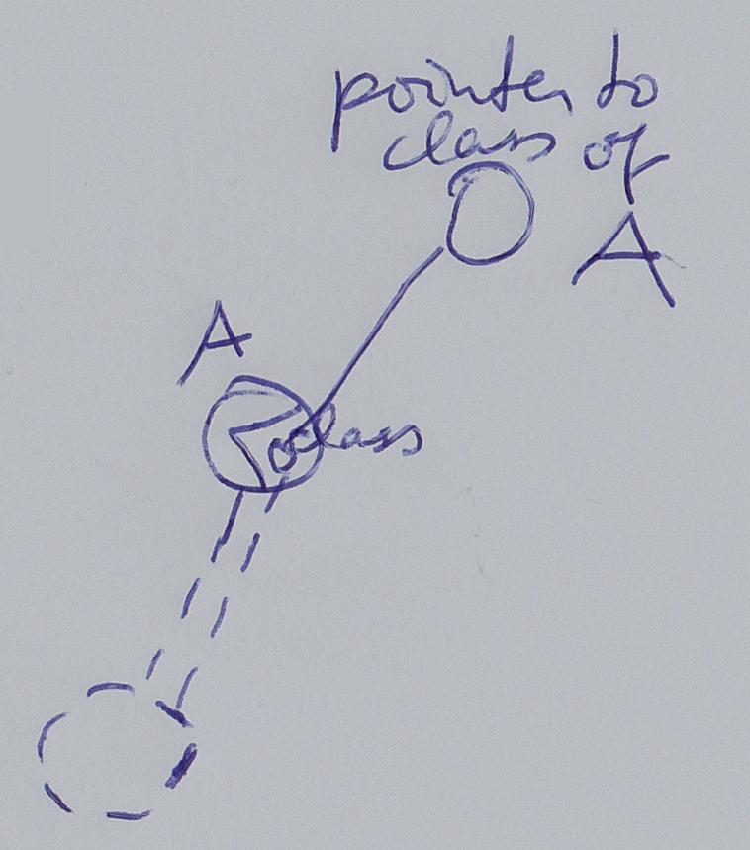

JJ

### Loose Ideas about Relation to a Pointer

Relations,

Relations to Pointers,

2008-09-25

Pointers (references to related objects)

A relation between a *pointer to an object* and a *command*. The* pointer is a totally different entity, than the* object itself.

> 2008-10-01 I’d think, that this will add related objects to the* system interface, so related objects to a related item system object, instead of related objects to the* target object of the* related item system object.  
This is a relations issue: relations to pointers in particuler.

I will need to look at *System Objects* to see what a pointer actually was: it was a relation to a related item, instead of a relation to an object independent of any other container.

JJ